BYOC course
Assignment #6

MIPS2 CPU

Appendices
Appendix A

A.1) Fill up the following table describing what happens in each CK cycle in all instructions. You should specify the specific operations that are required for the execution of the instruction.
We filled in the Rtype and j instructions – as examples.

phase | IF | ID | EX | MEM | WB
Instruction
Rtype | IR=IMem[PC]  PC=new value | A=Rs  B=Rt | ALUOUT =  A op B  Rd is chosen  Rd_pMEM=  Rd_pEX | ALUOUT_pWB=  ALUOUT  (ALUOUT is delayed 1 ck) | Rd=  ALUOUT_pWB
addi | IR=IMem[PC]  PC=new value | A=Rs  Sext_imm_reg = sext(imm) | ALUOUT =  A + Sext_imm_reg  Rt is chosen Rd_pMEM=Rt_pEX | ALUOUT_pWB=  ALUOUT  (ALUOUT is delayed 1 ck) | Rt = ALUOUT_pWB
ori | IR=IMem[PC]  PC=new value | A=Rs  Sext_imm_reg =  imm  Don’t do sign extension, just pass the imm value | ALUOUT =  A or sext_imm_reg  Rt is chosen  Rd_pMEM=Rt_pEX | ALUOUT_pWB=  ALUOUT  (ALUOUT is delayed 1 ck) | Rt = ALUOUT_pWB
lui | IR=IMem[PC]  PC=new value  Rs=0  Forcing Rs to be 0 | A=Rs  Sext_imm_reg =  Imm<16  Shifting left the imm 16 bits | ALUOUT =  A + sext_imm_reg  Rt is chosen  Rd_pMEM=Rt_pEX | ALUOUT_pWB=  ALUOUT  (ALUOUT is delayed 1 ck) | Rt = ALUOUT_pWB
beq | IR=IMem[PC]  PC=new value  PC_plus_4_pID=PC | If (Rs == Rt) {  PC = PC_plus_4_pID + sext(imm)<<2  } | nothing | nothing | Nothing
bne | IR=IMem[PC]  PC=new value  PC_plus_4_pID=PC | If (Rs != Rt) {  PC = PC_plus_4_pID + sext(imm)<<2  } | nothing | nothing | nothing
lw | IR=IMem[PC]  PC=new value | A=Rs  B=Rt  Sext_imm_reg=sext(imm) | ALUOUT = A + sext_imm_reg  Rt is chosen  Rd_pMEM=Rt_pEX | MDR = M[ALUOUT]  Rd_pWB = Rd_pMEM | Rt = MDR
sw | IR=IMem[PC]  PC=new value | A=Rs  B=Rt  Sext_imm_reg=sext(imm) | B_reg_pMEM = B  ALUOUT = A + sext_imm_reg | M[ALUOUT]=  B_reg_pMEM | nothing
j | IR=IMem[PC]  PC=new value | PC= jump adrs | nothing | nothing | Nothing
jal | IR=IMem[PC]  PC=new value  Rt=$31 | PC= jump address  Pc_plus_4_pEX =  Pc_plus_4_pID | Pc_plus_4_pMEM=  Pc_plus_4_pEX  Rt is chosen  Rd_pMEM=Rt_pEX | Pc_plus_4_pWB=  Pc_plus_4_pMEM  Rd_pWB = Rd_pMEM | Rt=  Pc_plus_4_  pWB
jr | IR=IMem[PC]  PC=new value | A=Rs | PC = A | Nothing | nothing

Answer the following questions.

A.2) Describe the changes done in order to support the ORI instruction.
ראשית, הוספנו שינוי לרכיב המבצע sign extension בFetch Unit ע"מ שירכיב את ה16 ביט אשר מגיעים מהפקודה ל32 מבלי לבצע sign extension במקרה והפקודה היא ORI.
הוספנו תמיכה בALUOP של ORI ברכיב הALU.
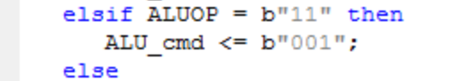
הוספנו לחלק הControl בשלב הInstruction Decode תמיכה בסיגנלים הנדרשים ע"מ לבצע את הפקודה החדשה, למעשה דומה מאוד לADDI שכבר מיממשנו, רק בשינוי הALUOP.
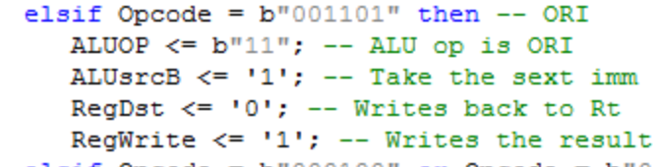
A.3) Describe the changes done in order to support the LUI instruction.
הופסנו שינוי לרכיב המבצע sign extension בFetch Unit ע"מ לעשות shift left 16 לimmediate ובכך נעביר לשלב הInstruction Decode כבר את הUpper Immediate בצורה הדרושה,
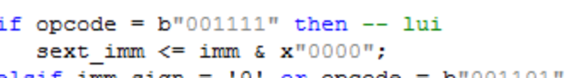
לאחר מכן נוסיף לחלק הControl בשלב הInstruction Decode תמיכה בפקודה LUI בכך שנשתמש באותם סיגנלים כמו בפקודה ADDI.
A.4) Describe the changes done in order to support the JR instruction.
את מרבית העבודה על הפקודה JR ביצענו בתרגילים הקודמים, על מנת לסיים את הפקודה היה עלינו "להעביר" את הכתובת אליה לקפוץ משלב הInstruction Decode בחזרה לFetch Unit שלנו, ביצענו זאת ע"י הוספת וקטור חדש אשר יעבור לFetch Unit בשם jr_address_in שיקבל את הוקטור jr_address שיכיל את התוכן היוצא מהGPR עבור הרגיסטר Rs כלומר את gpr_rd_data1 ובFetch Unit נשנה את הערך הקבוע שהיה עד כה ערך הקפיצה בוקטור החדש שלנו.
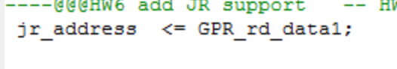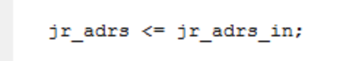
A.5) Describe the changes done in order to support the JAL instruction.
ראשית, היה עלינו "לפעפע" את הכתובת PC_plus_4 מהInstruction Fetch עד לשלב הWrite Back , ביצענו זאת ע"י שימוש בRegisters אשר יבצעו את ה"עיכוב" הדרוש. להלן דוגמה לקטע קוד של אחד הרגיסטרים:
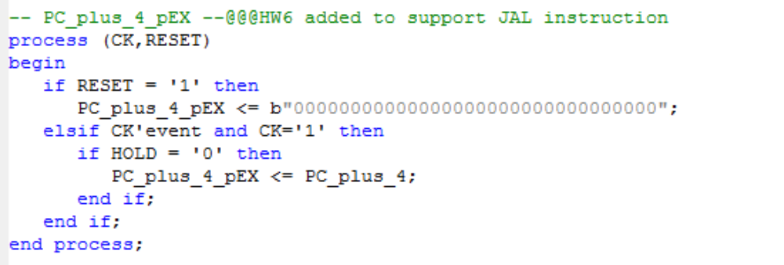
בנוסף, הוספנו לשלב הInstruction Decode בחלק הControl תמיכה בפקודה חדשה , JAL. בנוסף, היה עלינו לשנות את הMemToReg mux שיתמוך גם בפקודה החדשה, לשם כך היה עלינו להעביר סיגנל נוסף בשם JAL שגם כן "יפעפע" משלב הInstruction Decode עד לשלב הWrite Back שיודיע שזו פקודת JAL ושעלינו לקחת את הPC_plus_4_pWB ש"פעפענו" עד לשם אל תוך הRegister 31.

להלן קטע הקוד בחלק הControl בשלב הID:
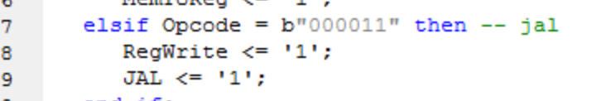
להלן קטע הקוד לאחר השינוי בMemToReg mux:
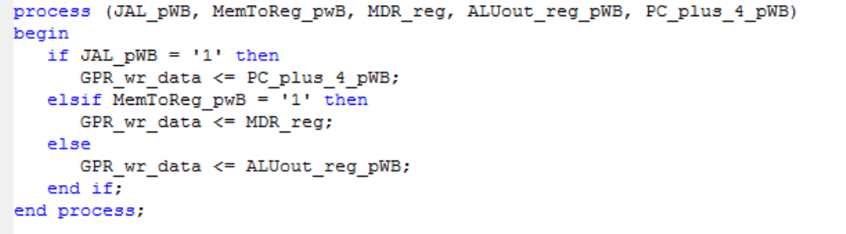
In your answers, besides stating the reasoning in detail, show the relevant VHDL code sections to better explain your answers.

In your answers, besides stating the reasoning in detail, show the relevant VHDL code sections to better explain your answers.

Appendix B

Answer the following questions.

B.1) What are the limitations due to the pipeline latency of the following combinations:
- lw after add where the add Rd is the lw Rs
- lw after add where the add Rd is the lw Rt
- add after lw where the lw Rt is the add Rt
- beq after lw where the lw Rt is the beq Rs

Use a similar figure to Fig.2 and Fig. 3 to demonstrate your answers.

WB
EX
ID
IF

WB
EX
ID
IF
WB
EX
ID
IF
NOP
NOP
add $3,$5,$8
WB
EX
ID
IF
NOP
WB
EX
ID
LW $9, 0($3)
IF
CK
MEM
MEM
MEM
MEM
MEM
EX

WB
EX
ID
IF
WB
EX
ID
IF
WB
EX
ID
IF
lw $3, 0($9)
add $3,$5,$8

WB
EX
ID
IF
WB
EX
ID
IF
CK
MEM
MEM
MEM
MEM
MEM
EX

WB
EX
ID
IF
WB
EX
ID
IF
WB
EX
ID
IF
NOP
NOP
lw $3,16($10)

WB
EX
ID
IF
NOP
WB
EX
ID
add $8, $5, $3
IF
CK
MEM
MEM
MEM
MEM
MEM
EX

WB
EX
ID
IF
WB
EX
ID
IF
WB
EX
ID
IF
NOP
NOP
lw $3,16($10)

WB
EX
ID
IF
NOP
WB
EX
ID
Beq $3, $5, label
IF
CK
MEM
MEM
MEM
MEM
MEM
EX

B.2) What are the limitations of all cases of B.1 after you add he Data Forwarding?
a) all limitations are gone
b) all limitations are gone
c) all limitations are gone
d) The NOPS stays - there is still need for branch_forwarding.

B.3) How many times do we perform the instruction following a jal instruction? Explain in detail. What are the implications? If this is a problem, what do you suggest in order to solve it?
We perform the next instruction twice. One is a clock right after the JAL is fetched, because in that clock the next instruction is fetched, and the second is when we return.
We can put NOP after the JAL.

B.4) How soon after jal instruction can we issue a jr $31 instruction in order to return to the right location in the code? Give the answer before data forwarding is added and then after the data forwarding is added

Before data forwarding:
4 instructions, because we have to wait for the WB phase of JAL.
After data forwarding:
3 instructions because of the transparent GPR.

Appendix C

Answer the following questions.

C.1) What are the limitations due to the pipeline latency of the following combinations (assume Data Forwarding already exists):
- beq after add where the add Rd is the beq Rt
- beq after lw where the lw Rt is the beq Rs

Use a similar figure to Fig.2 and Fig. 3 to demonstrate your answers.

WB
EX
ID
IF
WB
EX
ID
IF
WB
EX
ID
IF
NOP
NOP
add $3,$5,$8

WB
EX
ID
IF
Beq $9, $3, label
WB
EX
ID
IF
CK
MEM
MEM
MEM
MEM
MEM
EX

WB
EX
ID
IF
WB
EX
ID
IF
WB
EX
ID
IF
NOP
NOP
lw $3,16($10)

WB
EX
ID
IF
Beq $9, $3, label
WB
EX
ID
IF
CK
MEM
MEM
MEM
MEM
MEM
EX

C.2) What are the limitations of all cases of C.1 after you add the Branch Forwarding?
For beq after add:
WB
EX
ID
IF
WB
EX
ID
IF
WB
EX
ID
IF
NOP
Beq $9, $3, label

add $3,$5,$8

WB
EX
ID
IF
WB
EX
ID
IF
CK
MEM
MEM
MEM
MEM
MEM
EX

For beq after lw: The same as C1.

C.3) Why can’t we check the result of the previous instruction (time slot n-1) by a beq instruction following it (time slot n)?

Because the (n-1) instruction EX phase and the beq ID phase are executing concurrently, and beq might not get the correct value from the EX phase. We need a NOP, for letting the EX phase complete and then forward the value.

C.4) What is the shortest loop code possible? Any limitations? Explain in detail

LABEL: Add $2, $3, $4
nop
Beq $9, $10, LABEL
Nop

The limitations are:
- We need to execute a calculation, which is labeled, for the loop
- Before beq we need a NOP, because branch forwarding makes forward the data from the MEM phase of add, to ID phase of beq.
- Beq itself
- Need a NOP for not executing the next instruction twice.

